Q1:

Give state diagrams of DFAs recognizing the following languages. In all parts the

alphabet is {0,1 }

a. {w I w begins with a 1 and ends with a }

b. {w I w contains at least three 1s}

c. {w I w contains the substring 0101, i.e., w = x0101y for some x and y}

d. {w I w has length at least 3 and its third symbol is a 0}

e. {w I w starts with 0 and has odd length, or starts with 1 and has even length}

f {w I w doesn't contain the substring 1101}

g. {w| the length of w is at most 5}

h. {w l w is any string except 11 and 1111}

i. {w | every odd position of w is a 1}

j. {w I w contains at least two 0s and at most one 1}

k. {w I w contains an even number of 0s, or contains exactly two 1s}

l. The empty set

m. All strings except the empty string

Question 2

Give state diagrams of NFAs with the specified number of states recognizing each of the following languages. In all parts the alphabet is {0,1}.

a. The language {w I w ends with 001 with three states}

b. The language {w l w contains the substring 0101, i.e., w = x0101y for some x and y} with five states

c. The language {w I w contains an even number of 0s, or contains exactly two 1s} with six states

d. The language {0} with two states

e. The language 0\*1 \* O+ with three states

f The language 1\*(001+)\* with three states

g. The language {e} with one state

h. The language O\* with one state

Q3 Use the construction theorem give the state diagrams of NFAs recognizing the union of the languages described in

a. {w | w begins with a 1 and ends with a }

b. {w l w contains at least three 1s}

Q4 Use the construction theorem give the state diagrams of NFAs recognizing the union of the languages described in

1. {wl w contains the substring 0101, i.e., w = x0101y for some x and y}
2. {w | w doesn't contain the substring 1101}

Q5 Prove that every N FA can be converted to an equivalent one that has a single accept state

Q6 Let D {w I w contains an even number of a's and an odd number of b's and does not contain the substring ab}. Give a DFA with five states that recognizes D and a regular expression that generates D.

Q7 Let F be the language of all strings over {0,1} that do not contain a pair of 1s is that are separated by an odd number of symbols. Give the state diagram of a DFA with 5 states that recognizes F.

Q8:

a. Show that, if M is a DFA that recognizes language B, swapping the accept and non-accept states in M yields a new DFA that recognizes the complement of B. Conclude that the class of regular languages is closed under complement.

b. Show by giving an example that, if M is an NFA that recognizes language C, swapping the accept and non-accept states in M doesn't necessarily yield a new NFA that recognizes the complement of C. Is the class of languages recognized by NFAs closed under complement? Explain your answer.

Q9 : Convert these NFAs to DFAs

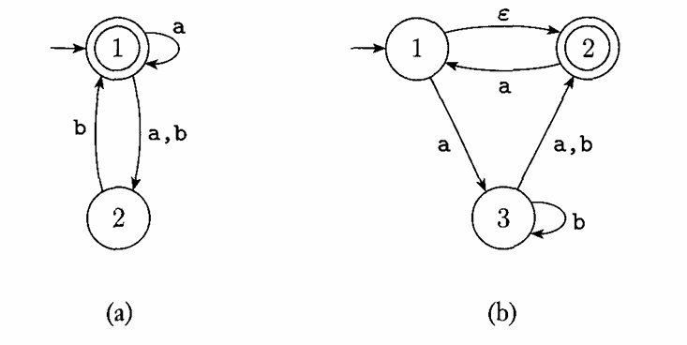

Q10:

Give an NFA recognizing the language (01 U 001 U 010)\*.

b. Convert this NFA to an equivalent DFA. Give only the portion of the DFA that is reachable from the start state.

Q11:

Give regular expressions generating the languages

a. {w I w begins with a 1 and ends with a }

b. {w I w contains at least three 1s}

c. {w I w contains the substring 0101, i.e., w = x0101y for some x and y}

d. {w I w has length at least 3 and its third symbol is a 0}

e. {w I w starts with 0 and has odd length, or starts with 1 and has even length}

f {w I w doesn't contain the substring 1101}

g. {w| the length of w is at most 5}

h. {w l w is any string except 11 and 1111}

i. {w | every odd position of w is a 1}

j. {w I w contains at least two 0s and at most one 1}

k. {w I w contains an even number of 0s, or contains exactly two 1s}

l. The empty set

m. All strings except the empty string

Q12:

Convert the following regular expressions to nondeterministic finite automata.

a. (0 U 1)\*000(0 U 1)\*

b. (((00)\*(11)) U 01)\*

Q13:

For each of the following languages, give two strings that are members and two strings that are not members --a total of four strings for each part. Assume the alphabet {a,b} in all parts.

Q14: Convert the following finite automata to regular expressions.

